

**Our Mission:**

**Making FRC Accessible to All**

From our inception in 2005 FRC Team 1719, The Umbrella Corporation, has had a consistent mission of engaging students both at our base, The Park School of Baltimore, and students from nearby schools without their own FRC programs. To date, students from seven schools in addition to Park have participated as active members of the team.

In addition to helping us fulfill our obligation to engage the broader community in science and engineering, these students and their families have been a rich source of talented and engaged students as well as valued mentors and supportive parents. The 2015 team is privileged to include six students from Dulaney High School and three from Owings Mills High School alongside 23 Park students.

**Engineering as a Design Process**

For the past four years, the team has focused on building a disciplined Engineering Culture into our design and build efforts. With the help of dedicated mentors, we have instituted and continue to apply techniques of engineering design, including

* Extensive use of CAD
* Formal student-led design reviews for major sub-systems.
* Continuous quality improvement through post-season evaluation and review
* Student leadership positions (Lead Engineer and Project Manager) with broad design and process accountability

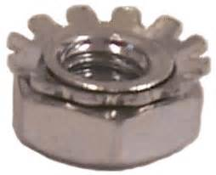

**Computer-Aided Design**

Like many teams, we were slow to appreciate the value of CAD in the design process. The steep learning curve to gain proficiency at these powerful tools just didn’t seem to work in a six-week build season.

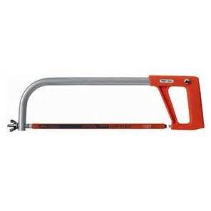

With the help of tutorial software donated by one of our sponsors, TEDCF Inc., we were able to overcome the learning curve problem and build a solid base of skills among many team members. CAD is now fundamental to much of our design and manufacturing efforts, including our custom-cut chassis systems, our use of 3D printing, and the ability to integrate various elements of the robot design.

**Our 2015 Robot**

In our breakdown of “Recycle Rush”, we determined that the key limiting factor in the game was the number of recycling bins available to each side. Since these triple the value of the tote stacks, we decided to specialize in handling the recycling bins. The particular design features we have incorporated include:

* Front-and-back elevators to manage two bins at once
* A telescoping, spring-loaded device for quickly harvesting bins from the step



Although we can manipulate the totes as well, our strategy is to rely on alliance partners for building tote stacks while we focus on obtaining and positioning the recycling bins to maximize the score.

**Team 1719 Sponsors**

The Umbrella Corporation gratefully acknowledges the generous financial and in-kind support of our sponsors:

* **Maryland Portable Concrete**
* **Harry W. Kaplan, M.D.**
* **Maryland Space Business Roundtable**
* **Lion Brothers, Inc. (10 Year supporter)**
* **Waterjet Cutting of Indiana**
* **Colors, Inc. of Indianapolis**
* **TEDCF, Inc.**
* **The Park School of Baltimore**
* **Friends and Family of Team 1719**

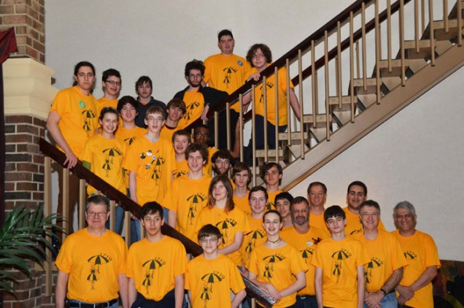



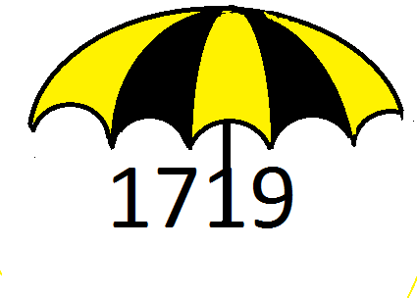**The**

**Umbrella Corporation Celebrates**

**10 Years**

**of FRC Success**

**with the 2015 game**

